1.

|  |  |  |  |  |
| --- | --- | --- | --- | --- |
| 17 | 23 | 5 | 11 | 2 |

Compare (17 and 23)(23 and 5)(23 and 11)(23 and 2)

|  |  |  |  |  |
| --- | --- | --- | --- | --- |
| 17 | 5 | 11 | 2 | 23 |

Compare (17 and 5)( 17 and 11)(17 and 2)

|  |  |  |  |  |
| --- | --- | --- | --- | --- |
| 5 | 11 | 2 | 17 | 23 |

Compare (5 and 11)(11 and 2)

|  |  |  |  |  |
| --- | --- | --- | --- | --- |
| 5 | 2 | 11 | 17 | 23 |

Compare (5 and 2)

|  |  |  |  |  |
| --- | --- | --- | --- | --- |
| 2 | 5 | 11 | 17 | 23 |

2.

|  |  |  |  |  |
| --- | --- | --- | --- | --- |
| 17 | 23 | 5 | 11 | 2 |

Find smallest is 2, switch with 17

|  |  |  |  |  |
| --- | --- | --- | --- | --- |
| 2 | 23 | 5 | 11 | 17 |

Next smallest 5, switch with 23

|  |  |  |  |  |
| --- | --- | --- | --- | --- |
| 2 | 5 | 23 | 11 | 17 |

Next smallest 11, switch with 23

|  |  |  |  |  |
| --- | --- | --- | --- | --- |
| 2 | 5 | 11 | 23 | 17 |

Next smallest 17, switch with 23

|  |  |  |  |  |
| --- | --- | --- | --- | --- |
| 2 | 5 | 11 | 17 | 23 |

3.

|  |  |  |  |  |
| --- | --- | --- | --- | --- |
| 17 | 23 | 5 | 11 | 2 |

Find position with (17 and 23)

|  |  |  |  |  |
| --- | --- | --- | --- | --- |
| 17 | 23 | 5 | 11 | 2 |

Find position 5 at 17 and 23

|  |  |  |  |  |
| --- | --- | --- | --- | --- |
| 5 | 17 | 23 | 11 | 2 |

Find position 11 at 5, 17,23

|  |  |  |  |  |
| --- | --- | --- | --- | --- |
| 5 | 11 | 17 | 23 | 2 |

Find position 2 at 5, 11, 17, 23

|  |  |  |  |  |
| --- | --- | --- | --- | --- |
| 2 | 5 | 11 | 17 | 23 |

4. the descending order should use max heap. If you need min just opposite

|  |  |  |  |  |
| --- | --- | --- | --- | --- |
| 17 | 23 | 5 | 11 | 2 |

Max heap

|  |  |  |  |  |
| --- | --- | --- | --- | --- |
| 23 | 17 | 5 | 11 | 2 |

Delete 23 and 2 become top.

|  |
| --- |
| 23 |

|  |  |  |  |
| --- | --- | --- | --- |
| 2 | 17 | 5 | 11 |

Max heap

|  |  |  |  |
| --- | --- | --- | --- |
| 17 | 11 | 5 | 2 |

Delete 17 and 2 become top

|  |  |
| --- | --- |
| 17 | 25 |

|  |  |  |
| --- | --- | --- |
| 2 | 11 | 5 |

Max heap

|  |  |  |
| --- | --- | --- |
| 11 | 2 | 5 |

Delete 11 and 5 become top

|  |  |  |
| --- | --- | --- |
| 11 | 17 | 25 |

|  |  |
| --- | --- |
| 5 | 2 |

Delete 5 and 2 become top

|  |  |  |  |  |
| --- | --- | --- | --- | --- |
| 2 | 5 | 11 | 17 | 25 |

5.

|  |  |  |  |  |  |
| --- | --- | --- | --- | --- | --- |
| 0 | 1 | 2 | 3 | 4 | 5 |
| \ | 17 | 23 | 5 | 11 | 2 |

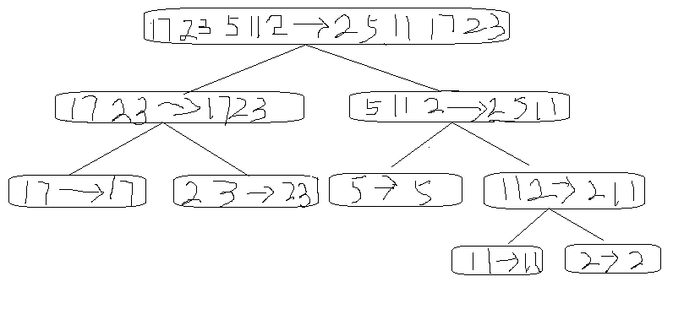

|  |  |  |  |  |  |
| --- | --- | --- | --- | --- | --- |
| 0 | 1 | 2 | 3 | 4 | 5 |
| \ | 2 | 5 | 11 | 17 | 23 |

6.

|  |  |  |  |  |  |
| --- | --- | --- | --- | --- | --- |
| 0 | 1 | 2 | 3 | 4 | 5 |
| \ | 17 | 23 | 5 | 11 | 2 |

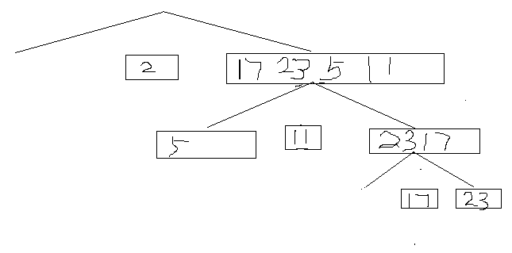

|  |  |  |  |  |  |
| --- | --- | --- | --- | --- | --- |
| 0 | 1 | 2 | 3 | 4 | 5 |
| \ | 2 | 5 | 11 | 17 | 23 |